FAKE NEWS DETECTION ON SOCIAL MEDIA

BLOCK DIAGRAMS :

Main Diagram :

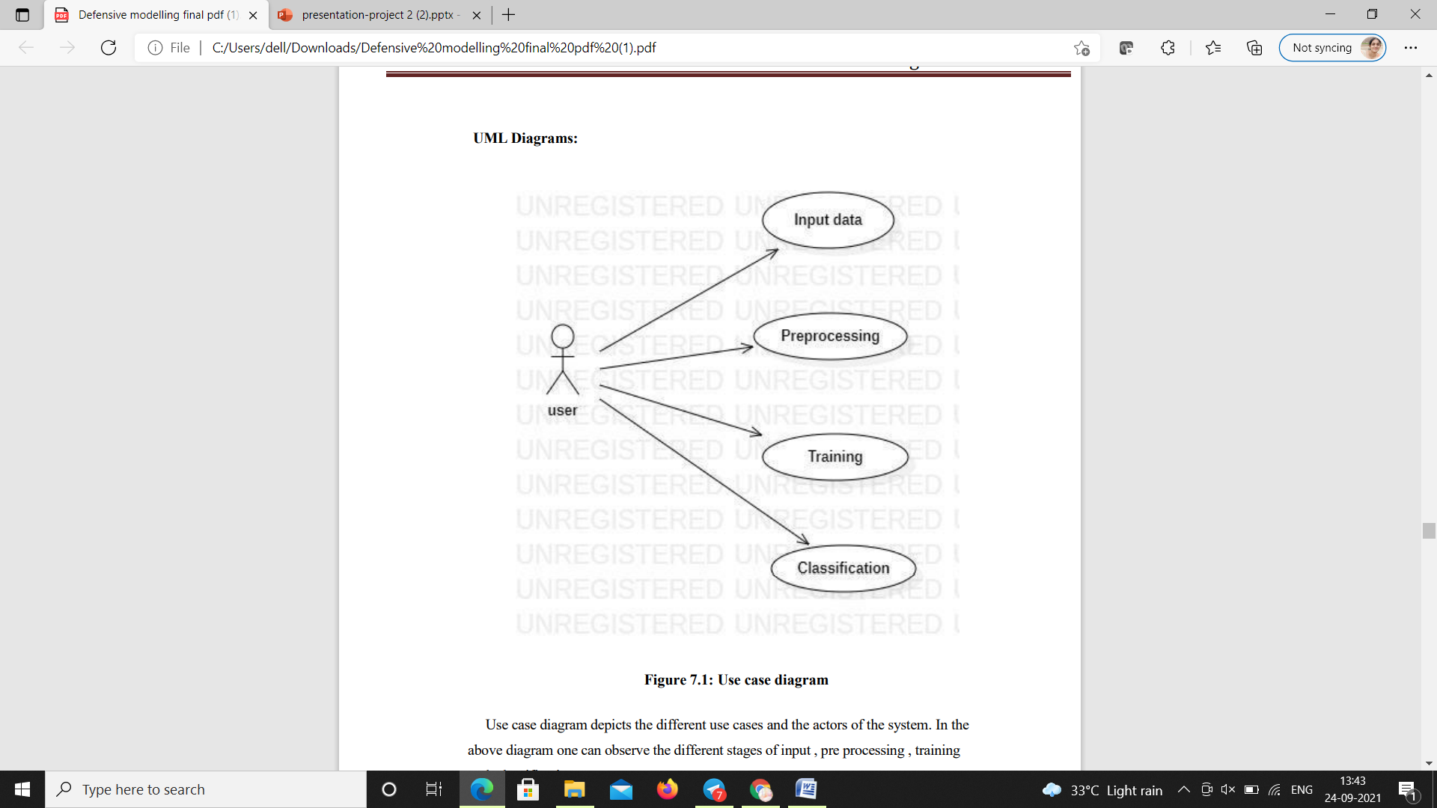

Sequence Diagram :

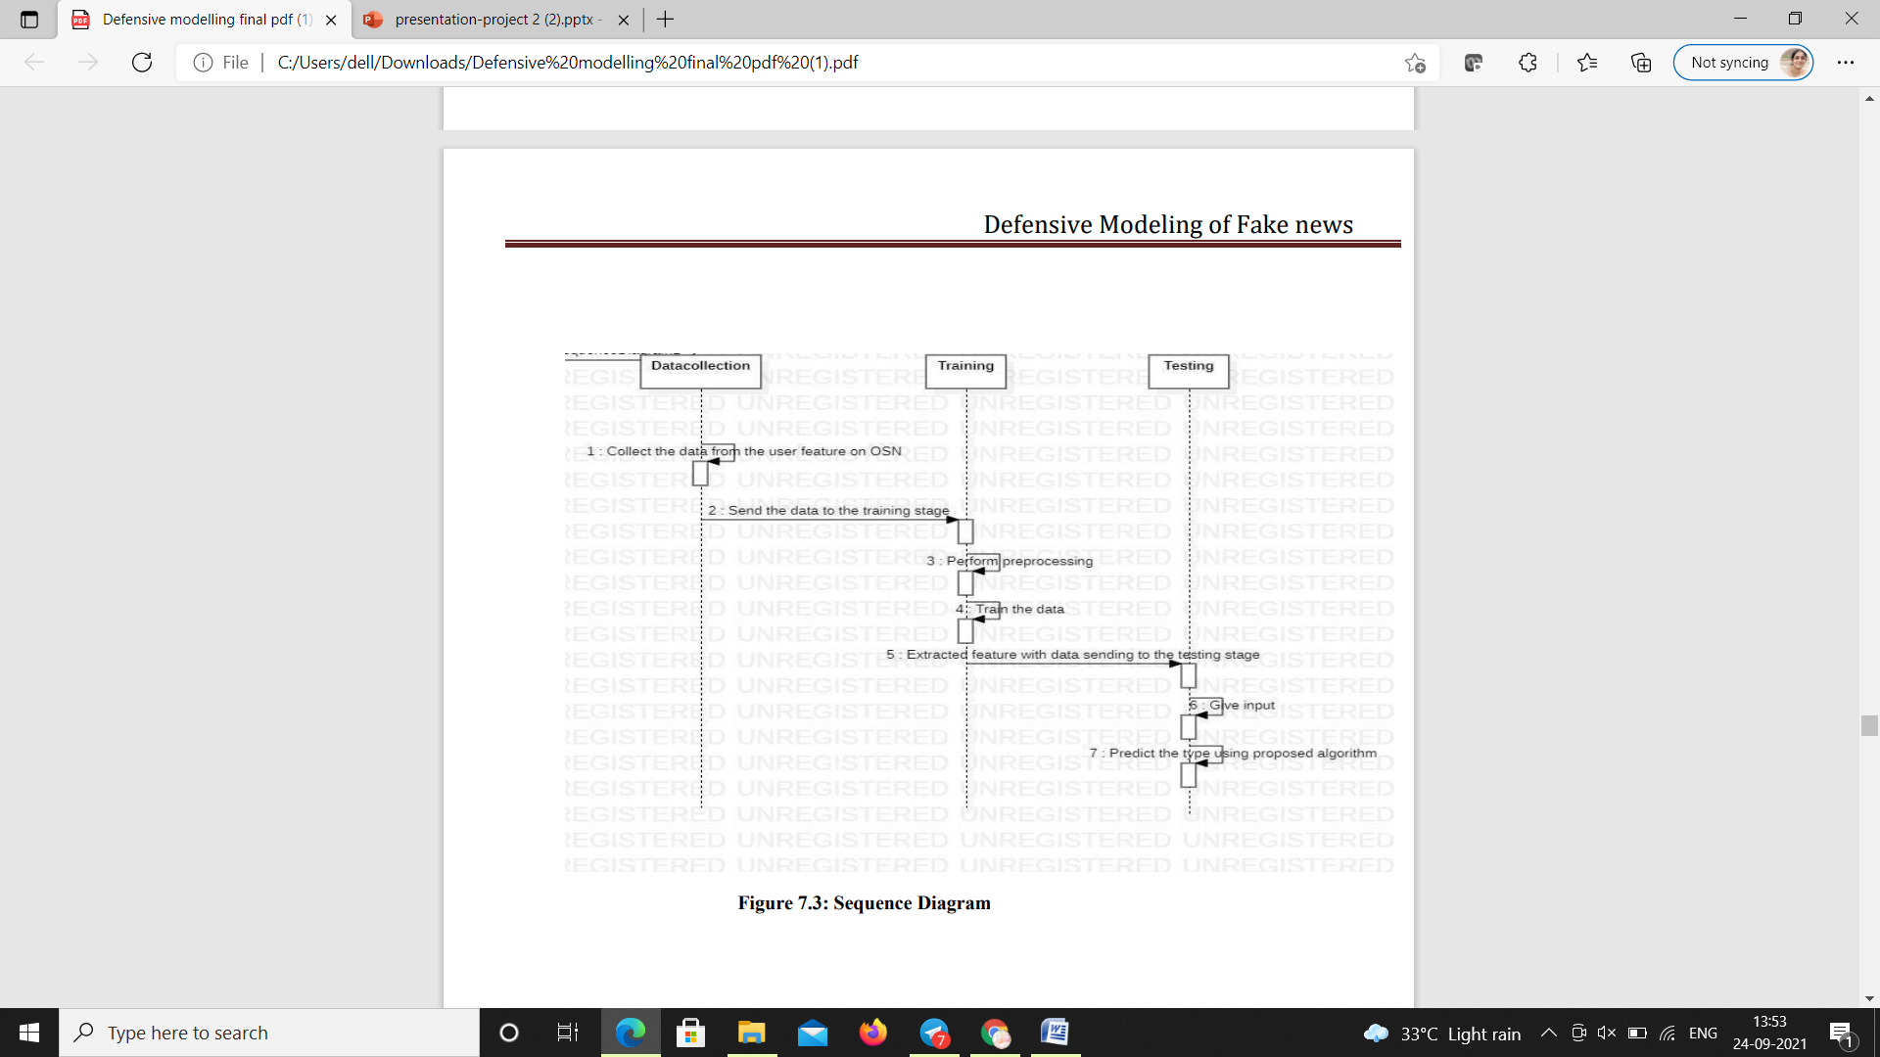

Activity Diagram:

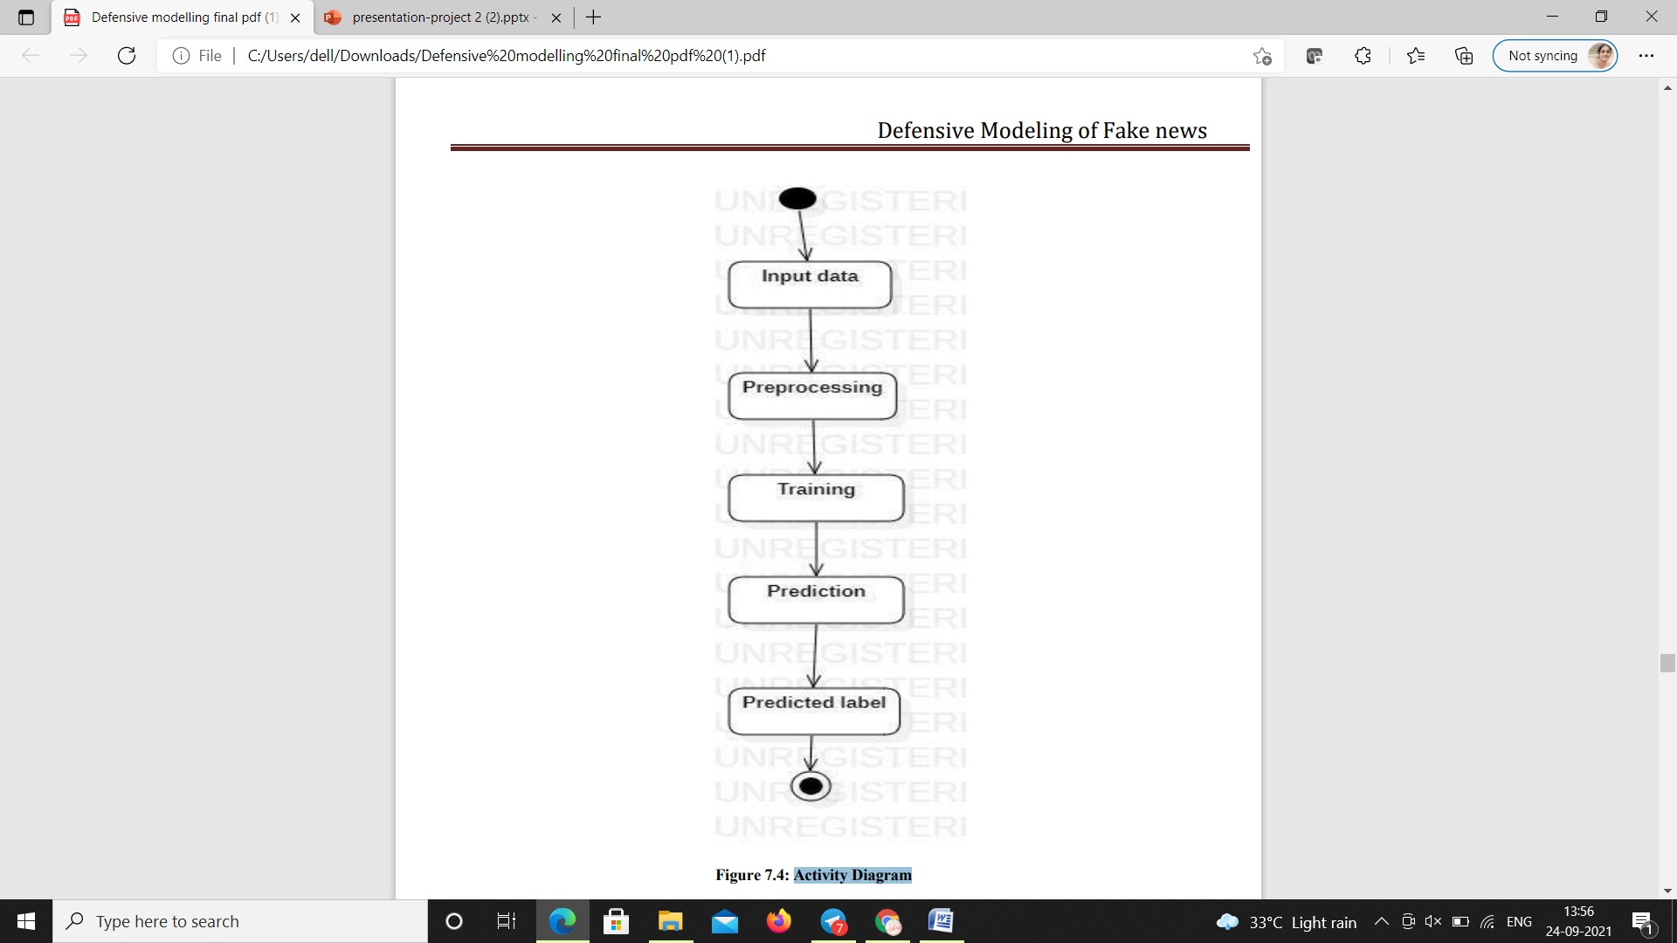

Collaboration Diagram :

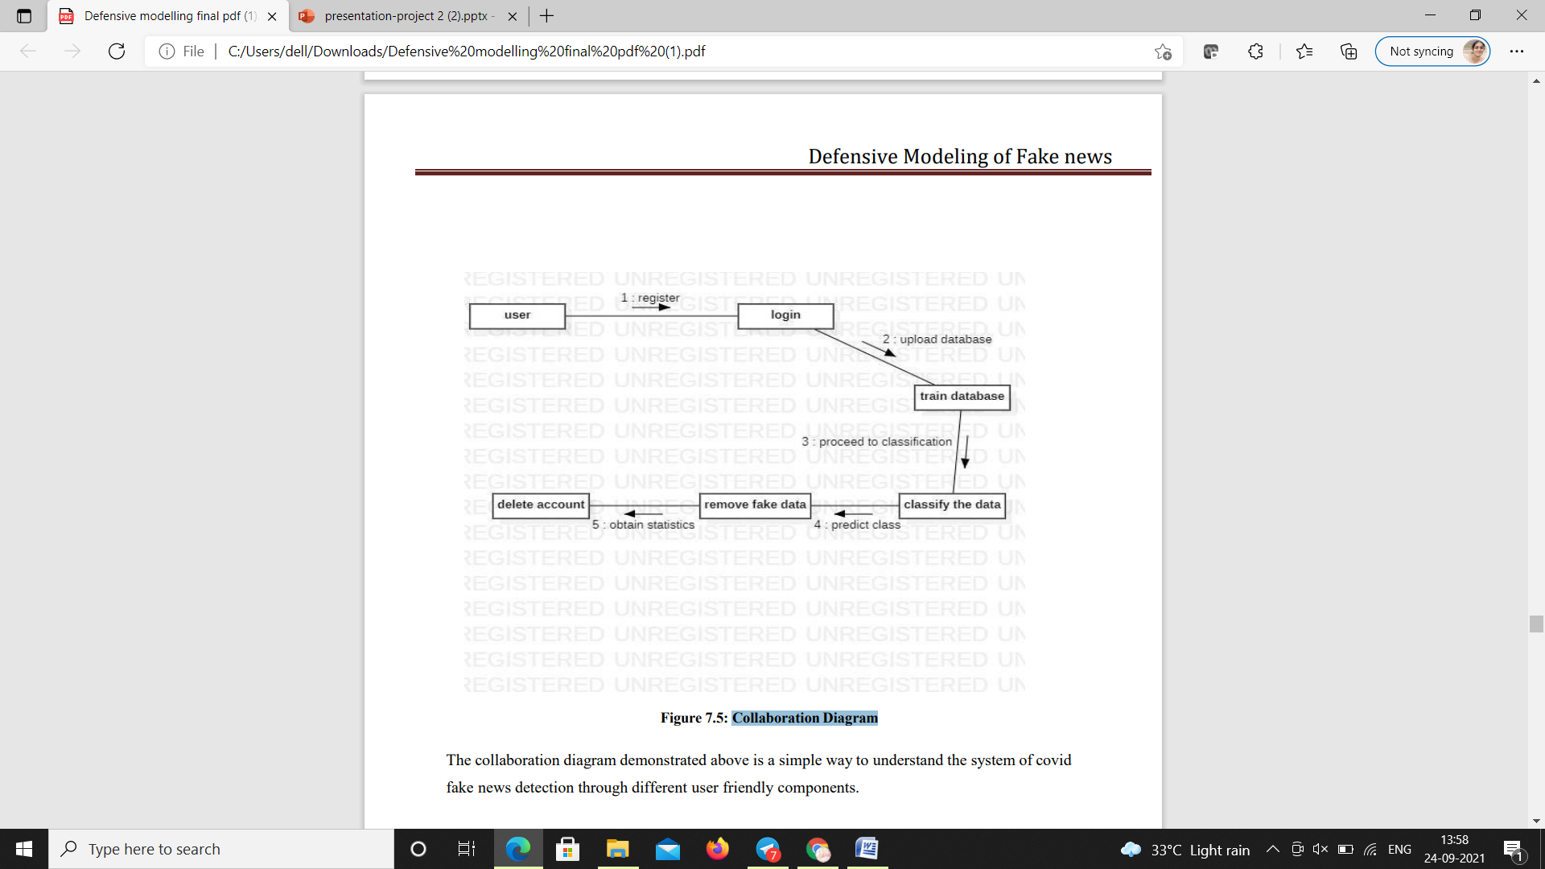

180030192 -K.LIKHITHA

180031450 - GAYATRI